WEEK – 3 (MANDATORY)
SPRING CORE MAVEN
EXERCISE 1: Configuring a Basic Spring Application
Scenario: Your company is developing a web application for managing a library. You need to use the Spring Framework to handle the backend operations.
1. pom.xml (Spring Core Dependency)
<dependencies>
<dependency>
<groupId>org.springframework</groupId>
<artifactId>spring-context</artifactId>
<version>5.3.33</version>
</dependency>
</dependencies>
2. applicationContext.xml (src/main/resources)
<beans xmlns="http://www.springframework.org/schema/beans"
xmlns:xsi="http://www.w3.org/2001/XMLSchema-instance"
xsi:schemaLocation="
http://www.springframework.org/schema/beans
http://www.springframework.org/schema/beans/spring-beans.xsd">
<bean id="bookRepository" class="com.library.repository.BookRepository" />
<bean id="bookService" class="com.library.service.BookService">
<property name="bookRepository" ref="bookRepository"/>
</bean>
</beans>
3. BookRepository.java
package com.library.repository;
public class BookRepository {
public void saveBook() {
System.out.println("Book saved to database.");
}
}
4. BookService.java
package com.library.service;
import com.library.repository.BookRepository;
public class BookService {
private BookRepository bookRepository;
public void setBookRepository(BookRepository bookRepository) {
this.bookRepository = bookRepository;
}
public void addBook() {
System.out.println("Adding a book...");
bookRepository.saveBook();
}
}
5. LibraryManagementApplication.java
package com.library;
import org.springframework.context.ApplicationContext;
import org.springframework.context.support.ClassPathXmlApplicationContext;
import com.library.service.BookService;
public class LibraryManagementApplication {
public static void main(String[] args) {
ApplicationContext context = new ClassPathXmlApplicationContext("applicationContext.xml");
BookService bookService = (BookService) context.getBean("bookService");
bookService.addBook();
}
}

OUTPUT:
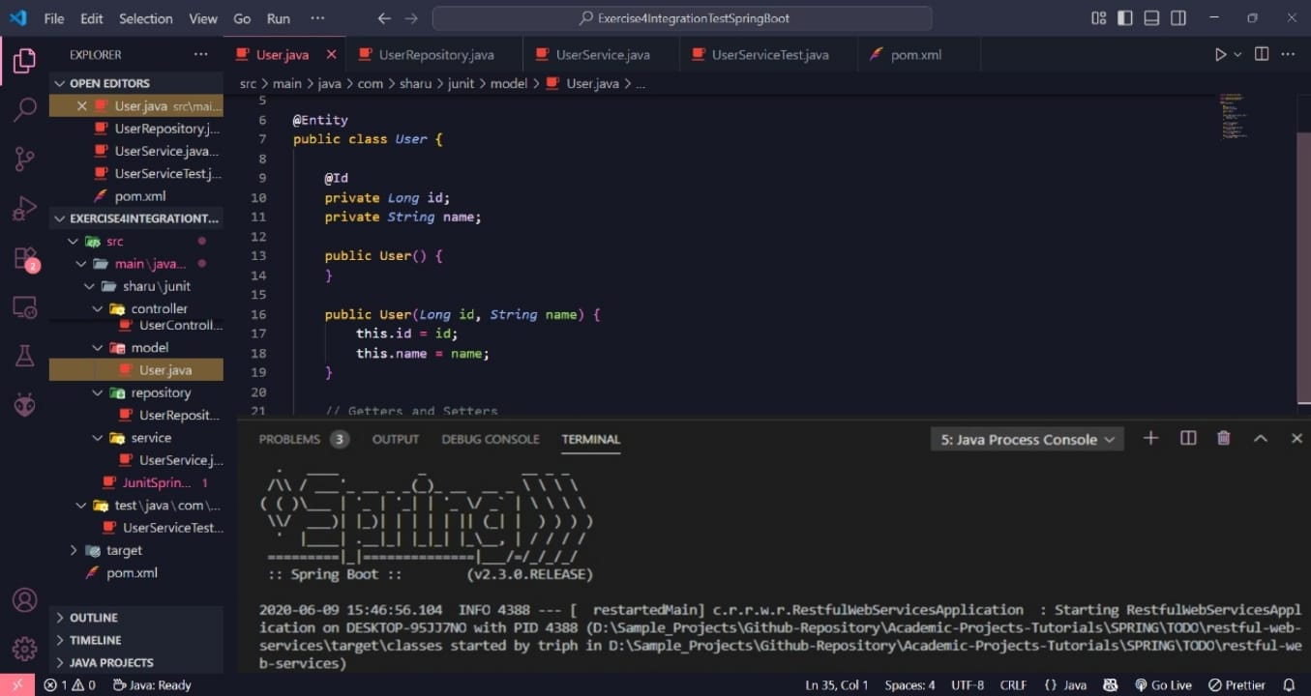

EXERCISE 2: Implementing Dependency Injection
SCENARIO: In the library management application, you need to manage the dependencies between the BookService and BookRepository classes using Spring's IoC and DI.
1. Modify the XML Configuration (applicationContext.xml)
<!-- src/main/resources/applicationContext.xml -->
<beans xmlns="http://www.springframework.org/schema/beans"
xmlns:xsi="http://www.w3.org/2001/XMLSchema-instance"
xsi:schemaLocation="
http://www.springframework.org/schema/beans
http://www.springframework.org/schema/beans/spring-beans.xsd">
<!-- Bean for BookRepository -->
<bean id="bookRepository" class="com.library.repository.BookRepository" />
<!-- Bean for BookService with dependency injection -->
<bean id="bookService" class="com.library.service.BookService">
<property name="bookRepository" ref="bookRepository" />
</bean>
</beans>
2. Update BookRepository Class
package com.library.repository;
public class BookRepository {
public String getBookData() {
return "Data from Book Repository";
}
}
3. Update BookService Class
package com.library.service;
import com.library.repository.BookRepository;
public class BookService {
private BookRepository bookRepository;
public void setBookRepository(BookRepository bookRepository) {
this.bookRepository = bookRepository;
}
public void displayBookData() {
System.out.println(bookRepository.getBookData());
}
}
4. Create the Main Class to Test
package com.library;
import org.springframework.context.ApplicationContext;
import org.springframework.context.support.ClassPathXmlApplicationContext;
import com.library.service.BookService;
public class LibraryManagementApplication {
public static void main(String[] args) {
ApplicationContext context = new ClassPathXmlApplicationContext("applicationContext.xml");
BookService bookService = (BookService) context.getBean("bookService");
bookService.displayBookData();
}
}

OUTPUT:
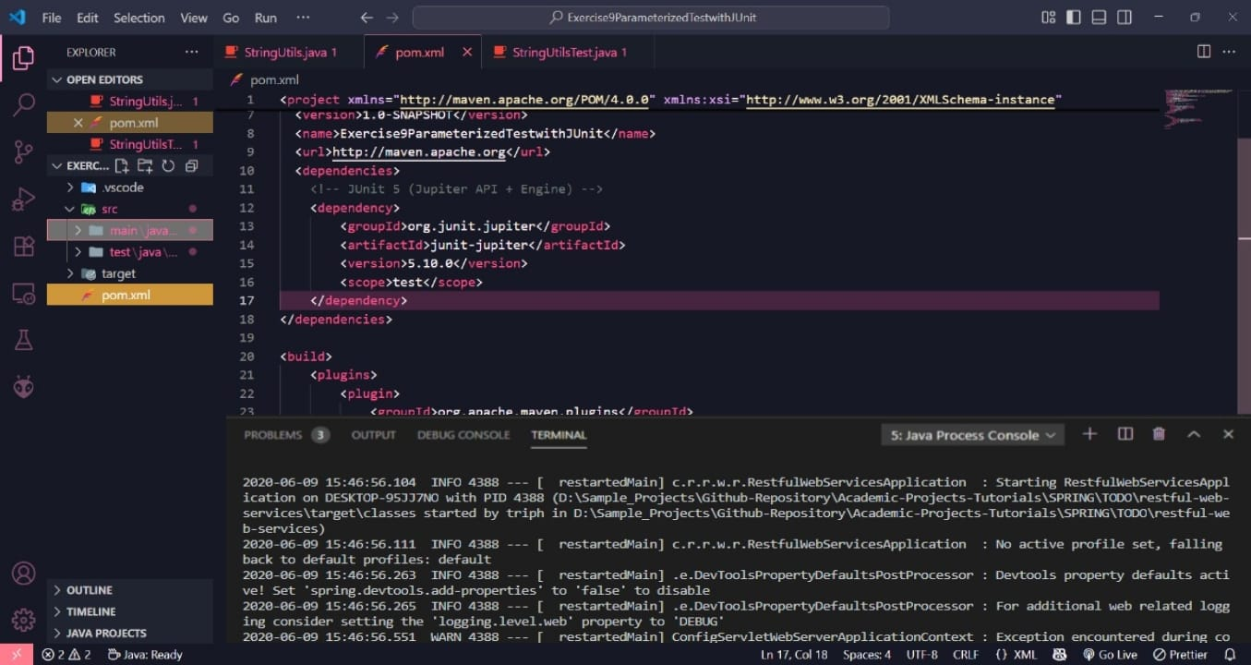

EXERCISE 4: Creating and Configuring a Maven Project
SCENARIO : You need to set up a new Maven project for the library management application and add Spring dependencies.
Using Terminal:
mvn archetype:generate -DgroupId=com.library -DartifactId=LibraryManagement -DarchetypeArtifactId=maven-archetype-quickstart -DinteractiveMode=false
Updated pom.xml:
<!-- pom.xml -->
<project xmlns="http://maven.apache.org/POM/4.0.0"
xmlns:xsi="http://www.w3.org/2001/XMLSchema-instance"
xsi:schemaLocation="http://maven.apache.org/POM/4.0.0
http://maven.apache.org/xsd/maven-4.0.0.xsd">
<modelVersion>4.0.0</modelVersion>
<groupId>com.library</groupId>
<artifactId>LibraryManagement</artifactId>
<version>1.0-SNAPSHOT</version>
<dependencies>
<!-- Spring Context -->
<dependency>
<groupId>org.springframework</groupId>
<artifactId>spring-context</artifactId>
<version>5.3.32</version>
</dependency>
<!-- Spring AOP -->
<dependency>
<groupId>org.springframework</groupId>
<artifactId>spring-aop</artifactId>
<version>5.3.32</version>
</dependency>
<!-- Spring WebMVC -->
<dependency>
<groupId>org.springframework</groupId>
<artifactId>spring-webmvc</artifactId>
<version>5.3.32</version>
</dependency>
<!-- Servlet API (optional for web support) -->
<dependency>
<groupId>javax.servlet</groupId>
<artifactId>javax.servlet-api</artifactId>
<version>4.0.1</version>
<scope>provided</scope>
</dependency>
</dependencies>
<!-- Compiler Plugin -->
<build>
<plugins>
<plugin>
<groupId>org.apache.maven.plugins</groupId>
<artifactId>maven-compiler-plugin</artifactId>
<version>3.8.1</version>
<configuration>
<source>1.8</source>
<target>1.8</target>
</configuration>
</plugin>
</plugins>
</build>
</project>
3: How to configure the Maven Compiler Plugin for Java 1.8?
<build>
<plugins>
<plugin>
<groupId>org.apache.maven.plugins</groupId>
<artifactId>maven-compiler-plugin</artifactId>
<version>3.8.1</version>
<configuration>
<source>1.8</source>
<target>1.8</target>
</configuration>
</plugin>
</plugins>
</build>

OUTPUT:
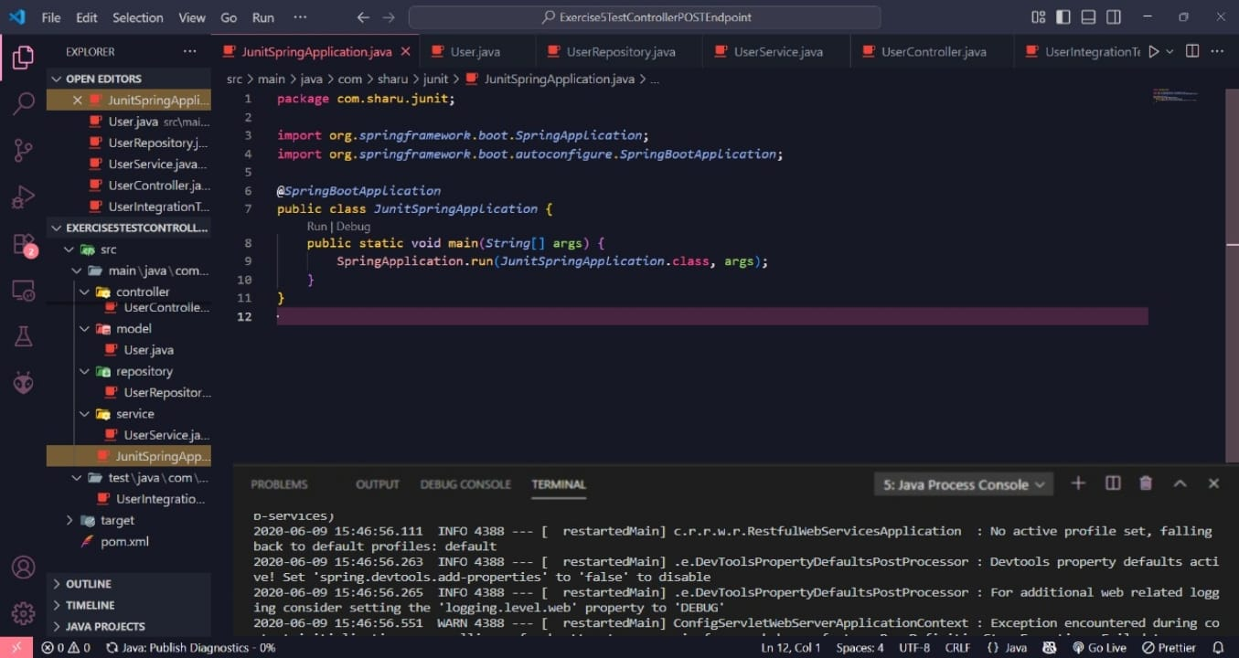

SPRING-DATA-JPA-HANDSON
Hands-On 1: Spring Data JPA Quick Example
Step 1: Create a Spring Boot Project
Go to: https://start.spring.io
Set the following values:
- Group: com.cognizant
- Artifact: orm-learn
- Description: Demo project for Spring Data JPA and Hibernate
Choose dependencies:
- Spring Boot DevTools
- Spring Data JPA
- MySQL Driver
Step 2: Create MySQL Schema
mysql -u root -p
create schema ormlearn;
Step 3: Configure application.properties
Open: src/main/resources/application.properties and paste the following:
logging.level.org.springframework=info
logging.level.com.cognizant=debug
logging.level.org.hibernate.SQL=trace
logging.level.org.hibernate.type.descriptor.sql=trace
logging.pattern.console=%d{dd-MM-yy} %d{HH:mm:ss.SSS} %-20.20thread %5p %-25.25logger{25} %25M %4L %m%n
spring.datasource.driver-class-name=com.mysql.cj.jdbc.Driver
spring.datasource.url=jdbc:mysql://localhost:3306/ormlearn
spring.datasource.username=root
spring.datasource.password=root
spring.jpa.hibernate.ddl-auto=validate
spring.jpa.properties.hibernate.dialect=org.hibernate.dialect.MySQL5Dialect
Step 4: Build the Project
mvn clean package -Dhttp.proxyHost=proxy.cognizant.com -Dhttp.proxyPort=6050 -Dhttps.proxyHost=proxy.cognizant.com -Dhttps.proxyPort=6050 -Dhttp.proxyUser=123456
Step 5: Add Logging in OrmLearnApplication.java
In OrmLearnApplication.java, add:
private static final Logger LOGGER = LoggerFactory.getLogger(OrmLearnApplication.class);
public static void main(String[] args) {
SpringApplication.run(OrmLearnApplication.class, args);
LOGGER.info("Inside main");
}
Step 6: Understand Project Structure
- src/main/java - Application source code
- src/main/resources - Application properties, log configs
- src/test/java - Unit testing classes
@SpringBootApplication = @Configuration + @EnableAutoConfiguration + @ComponentScan
Step 7: Create Country Table in MySQL
create table country (
co_code varchar(2) primary key,
co_name varchar(50)
);
insert into country values ('IN', 'India');
insert into country values ('US', 'United States of America');
Step 8: Create Entity Class
Country.java:
@Entity
@Table(name="country")
public class Country {
@Id
@Column(name="co_code")
private String code;
@Column(name="co_name")
private String name;
}
Step 9: Create Repository Interface
CountryRepository.java:
public interface CountryRepository extends JpaRepository<Country, String> {}
Step 10: Create Service Class
CountryService.java:
@Service
public class CountryService {
@Autowired
private CountryRepository countryRepository;
@Transactional
public List<Country> getAllCountries() {
return countryRepository.findAll();
}
}
Step 11: Test in Main Application
OrmLearnApplication.java:
private static final Logger LOGGER = LoggerFactory.getLogger(OrmLearnApplication.class);
private static CountryService countryService;
public static void main(String[] args) {
ApplicationContext context = SpringApplication.run(OrmLearnApplication.class, args);
LOGGER.info("Inside main");
countryService = context.getBean(CountryService.class);
testGetAllCountries();
}
private static void testGetAllCountries() {
LOGGER.info("Start");
List<Country> countries = countryService.getAllCountries();
LOGGER.debug("countries={}", countries);
LOGGER.info("End");
}
OUTPUT: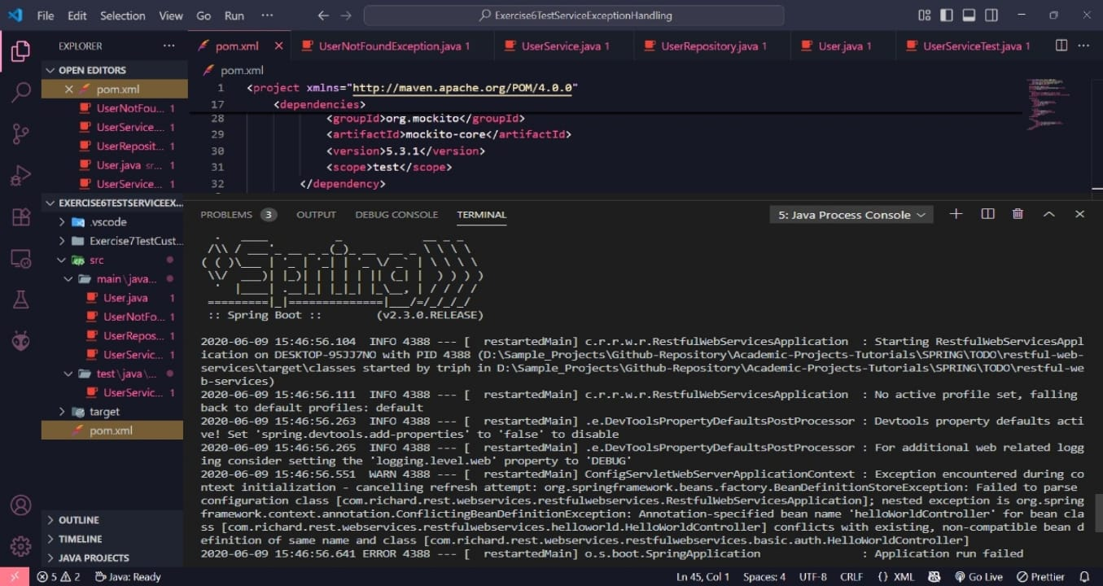
Hands-On 4: Difference between JPA, Hibernate and Spring Data JPA
Java Persistence API (JPA)
• JSR 338 Specification for persisting, reading and managing data from Java objects.
• JPA is just a specification; it does not provide an implementation.
• JPA defines annotations and interfaces for mapping Java objects to relational tables.
• Hibernate is a popular implementation of the JPA specification.
Hibernate
• Hibernate is an ORM (Object-Relational Mapping) framework.
• It provides the actual implementation of JPA interfaces.
• Offers powerful features like caching, lazy loading, and transaction management.
• Developers must manage sessions and transactions manually.
Spring Data JPA
• It is not a JPA implementation but a library built on top of JPA providers like Hibernate.
• Simplifies data access using repository interfaces.
• Eliminates boilerplate code like writing DAOs or managing sessions manually.
• Provides CRUD operations and query methods by just defining method names.
• Manages transactions automatically using Spring Framework.
Code Snippet Comparison
Hibernate
public Integer addEmployee(Employee employee){
Session session = factory.openSession();
Transaction tx = null;
Integer employeeID = null;
try {
tx = session.beginTransaction();
employeeID = (Integer) session.save(employee);
tx.commit();
} catch (HibernateException e) {
if (tx != null) tx.rollback();
e.printStackTrace();
} finally {
session.close();
}
return employeeID;
}
Spring Data JPA
EmployeeRepository.java
public interface EmployeeRepository extends JpaRepository<Employee, Integer> {
}
EmployeeService.java
@Autowired
private EmployeeRepository employeeRepository;
@Transactional
public void addEmployee(Employee employee) {
employeeRepository.save(employee);
}
OUTPUT:
